Database System Engineering and Distributed Backend Development
Course Code: 25CS13002E
WEEK-1 2520030527
K.Vansika Reddy

Query 1 — Create Database
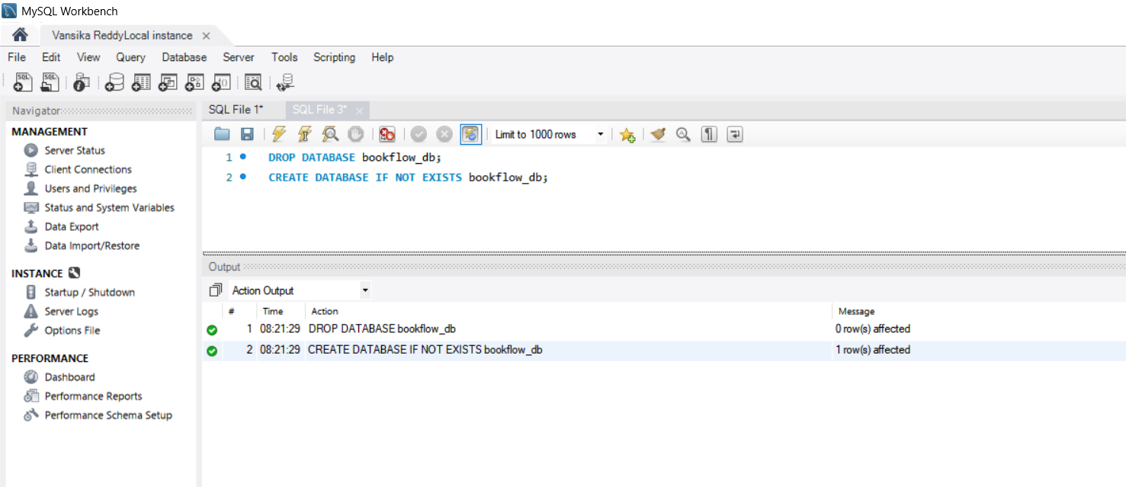

Query 2 – Select the Database
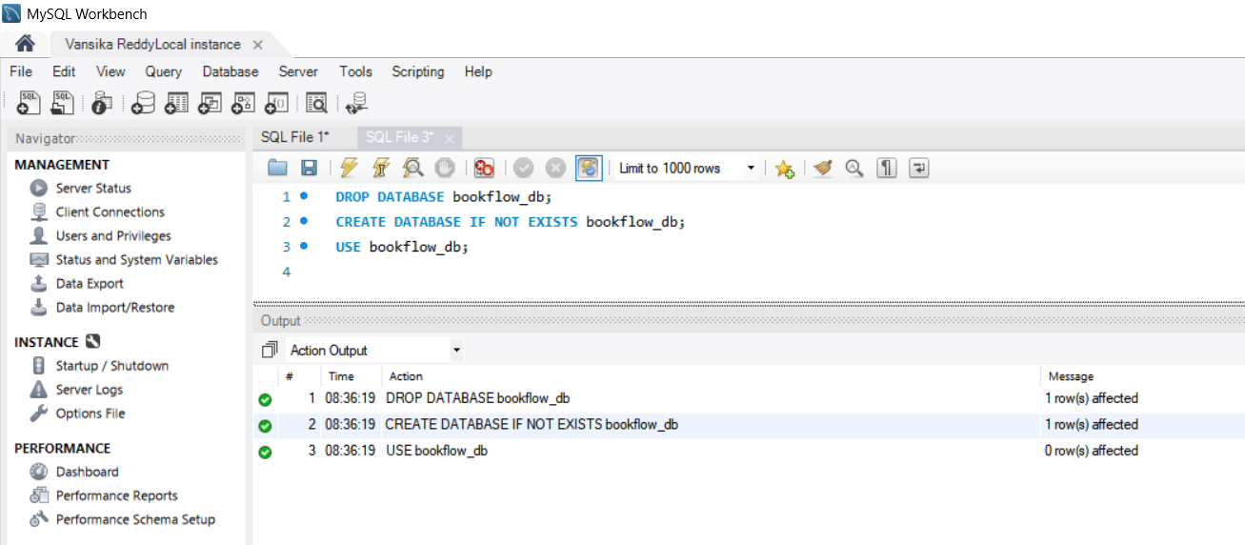
Query – 3 Create the books table
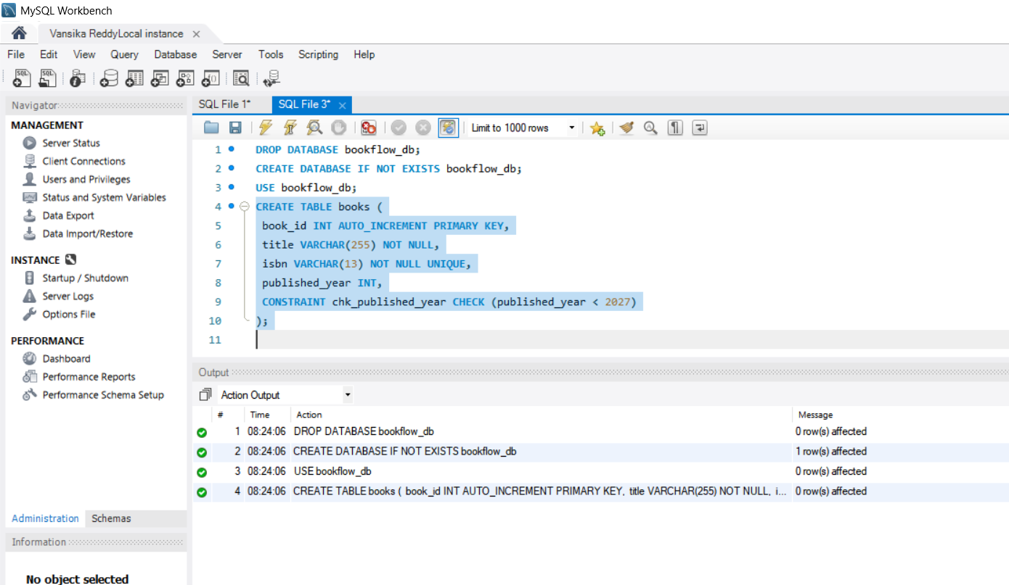

Query – 4 Create the members table
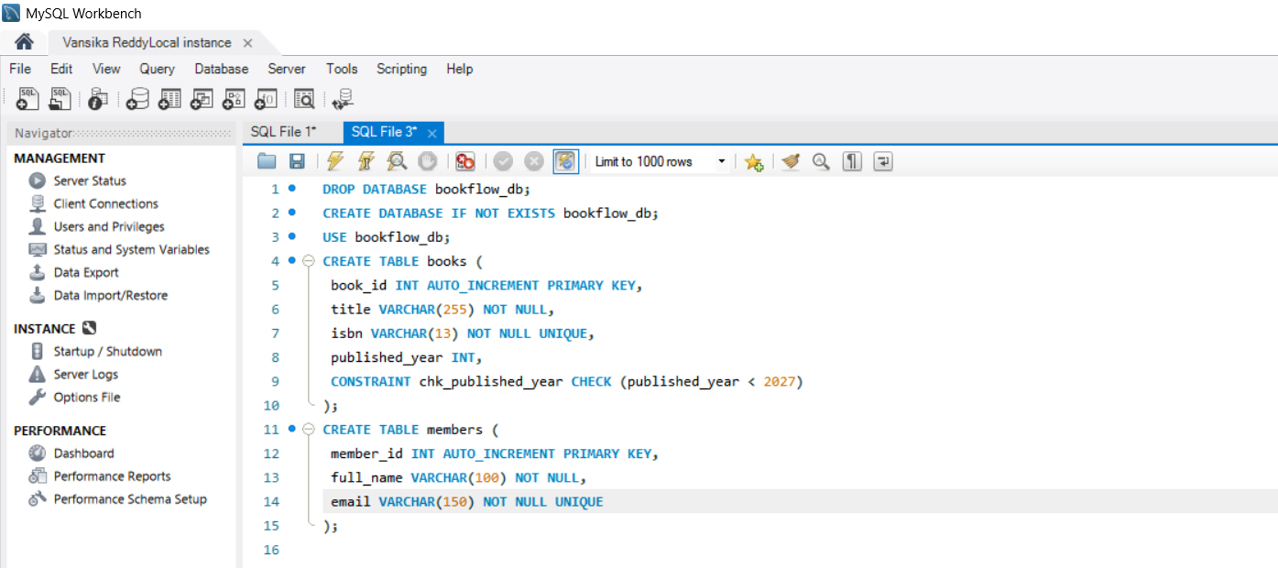

OUTPUT

Query – 5 (verification): Inspect the table structures:
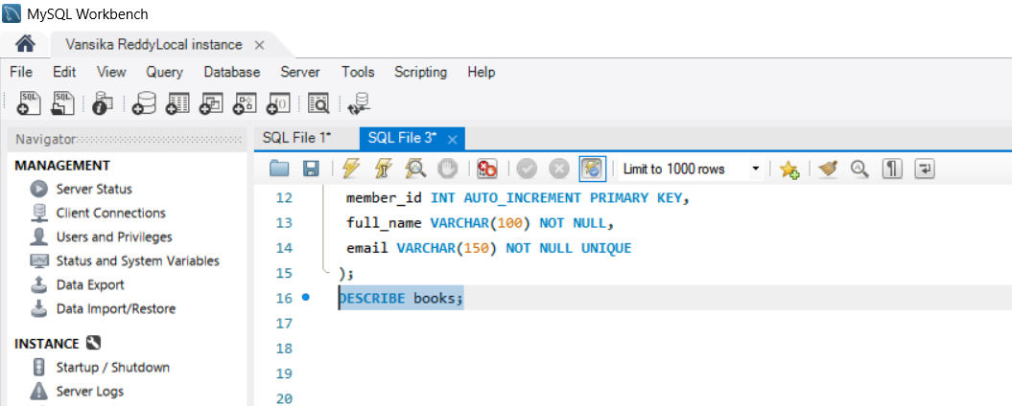
OUTPUT
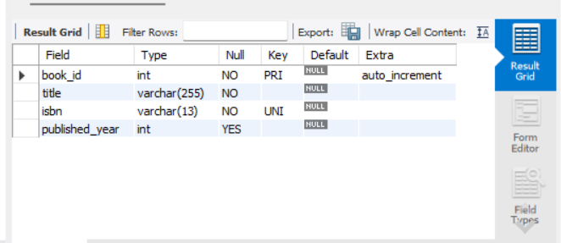

Query – 6: Insert 3 books
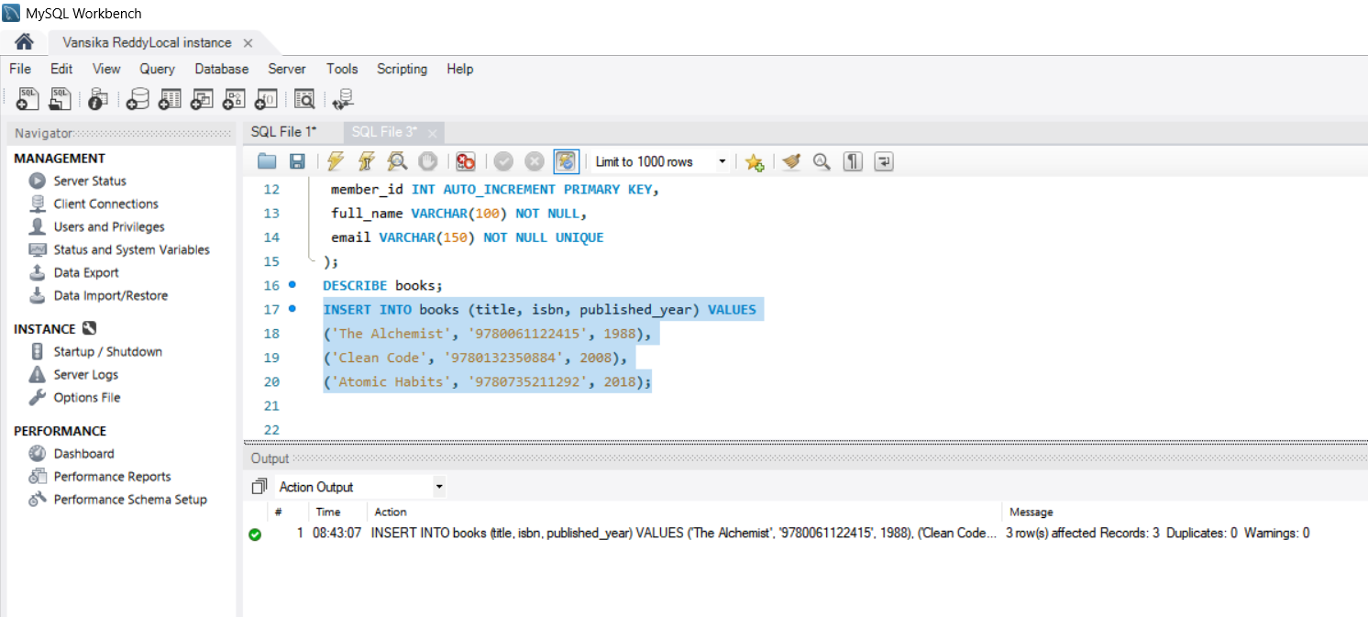

Query – 7 Insert 3 members
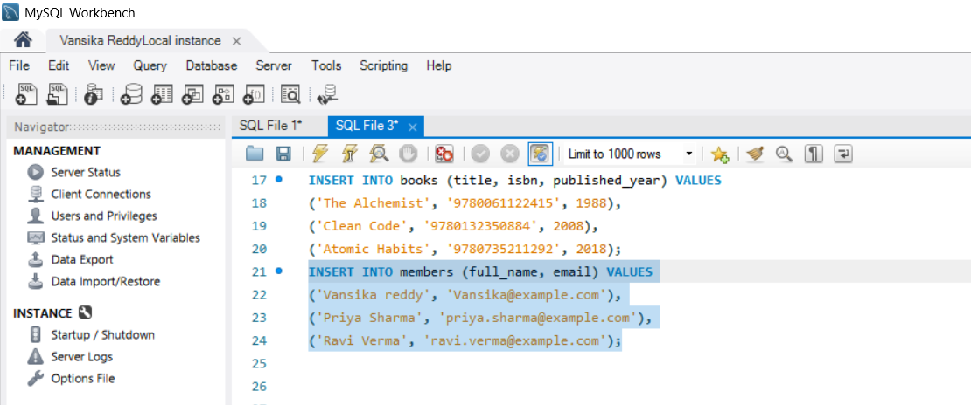

OUTPUT

Query – 8:
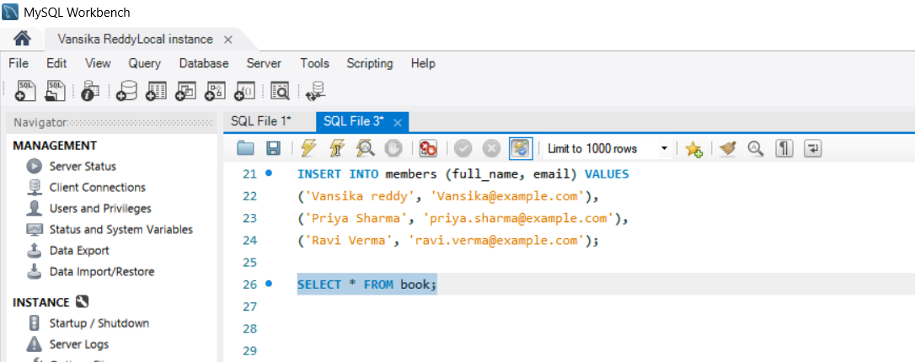

OUTPUT
